MEMORANDUM

DEPARTMENT OF TRANSPORTATION
Project Development Branch, Standards and Specifications Unit

4201 East Arkansas Avenue
Denver, Colorado 80222
(303)757-9474
FAX (303)757-9820
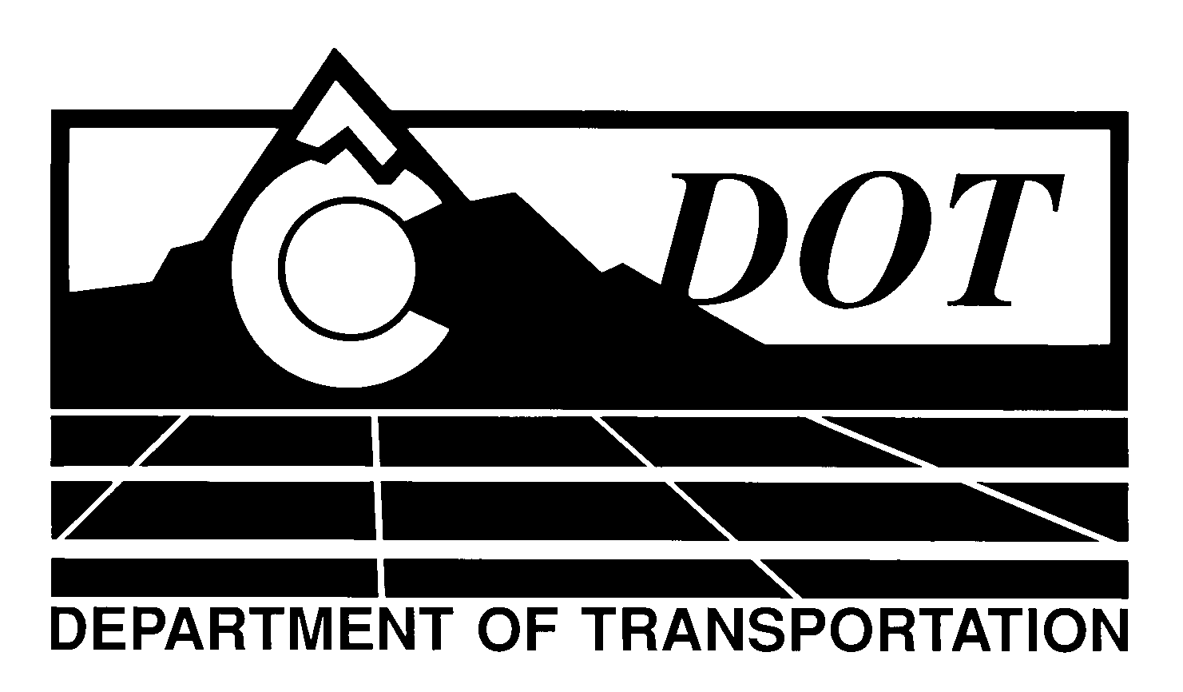

DATE: May 2, 2013

TO: All Holders of Standard Special Provisions

FROM: Larry Brinck, Standards and Specifications Engineer

SUBJECT: Revision of Section 108, Liquidated Damages

The attached document is a revised version of the standard special provision, Revision of Section 108, Liquidated Damages. This revised standard special provision is 1 page long. It replaces and makes obsolete the standard special provision of the same title, dated December 29, 2011. This revision is only to be used in all projects advertised on or after July 1, 2013. You may not use this revised version before this date.

This revised standard special upgrades the liquidated damages which are to be re-determined every two years. The new values have been reviewed and approved by the FHWA.

Those of you who keep books of Standard Special Provisions should replace the now obsolete standard special in your file with this revised version. The CDOT Construction Specifications web site has been updated to reflect the issuance of this and other special provisions.

For your convenience, however, you will find this new standard special provision and other special provisions that have been issued effective this date in one place on the web site:

http://www.coloradodot.info/business/designsupport/construction-specifications/2011-Specs/recently-issued-special-provisions

If you have any questions or comments, please contact this office.

LB/ms

Attachments

Distribution: Per distribution list

